Mohammed Tauseef Asif Shaikh

GitHub-

Docker POC

Objective: Containerize a full-stack application — a Node.js/Express frontend and a Flask backend — using Docker and Docker Compose, then push the images to Docker Hub and the code to GitHub.

1. Frontend (Node.js with Express)
- Create a frontend using Express and Node.js.

Explanation- The frontend/package.json file configures the project properties and manages the Express library dependency.
Source Code-
{
"name": "docker-frontend",
"version": "1.0.0",
"main": "server.js",
"dependencies": {
"express": "^4.19.2"
}
}
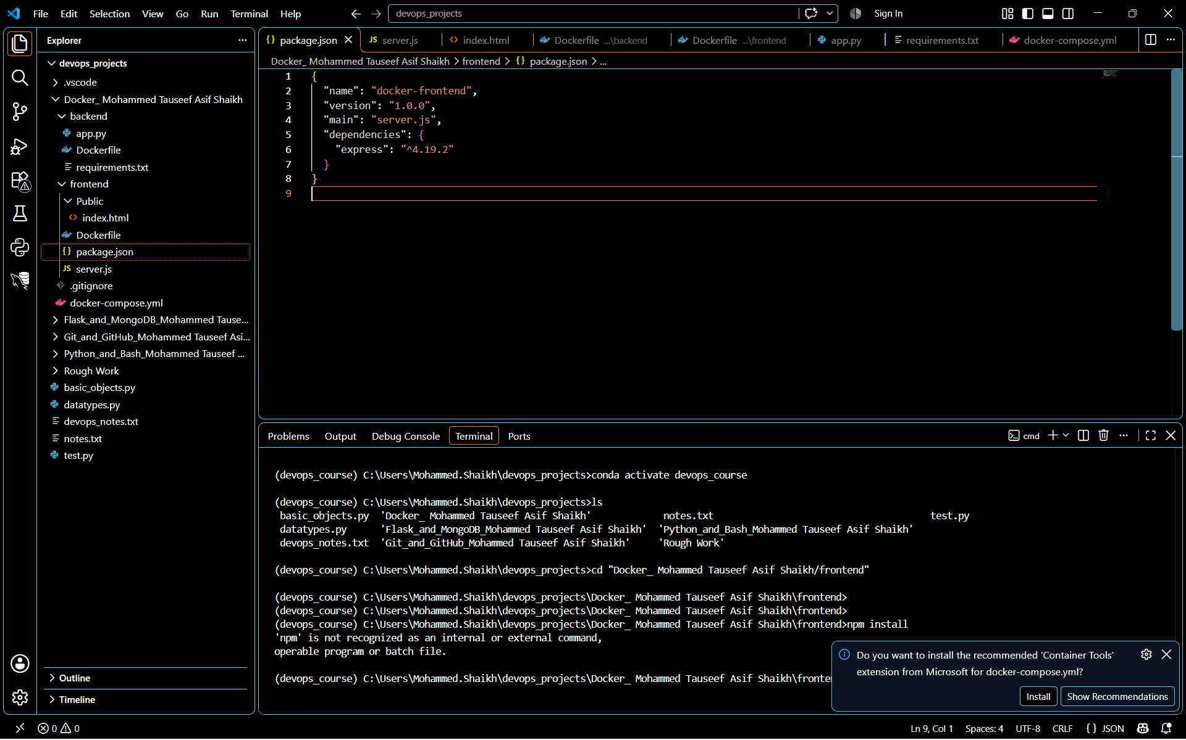

Explanation- The frontend/server.js file initialises Express, points to a static public assets folder (public), and specifies the networking port.
Source Code-
const express = require('express');
const path = require('path');
const app = express();
const PORT = 3000;

// Serve static elements from the public directory
app.use(express.static(path.join(__dirname, 'public')));

app.listen(PORT, () => {
console.log(`Frontend UI server running on port ${PORT}`);
});
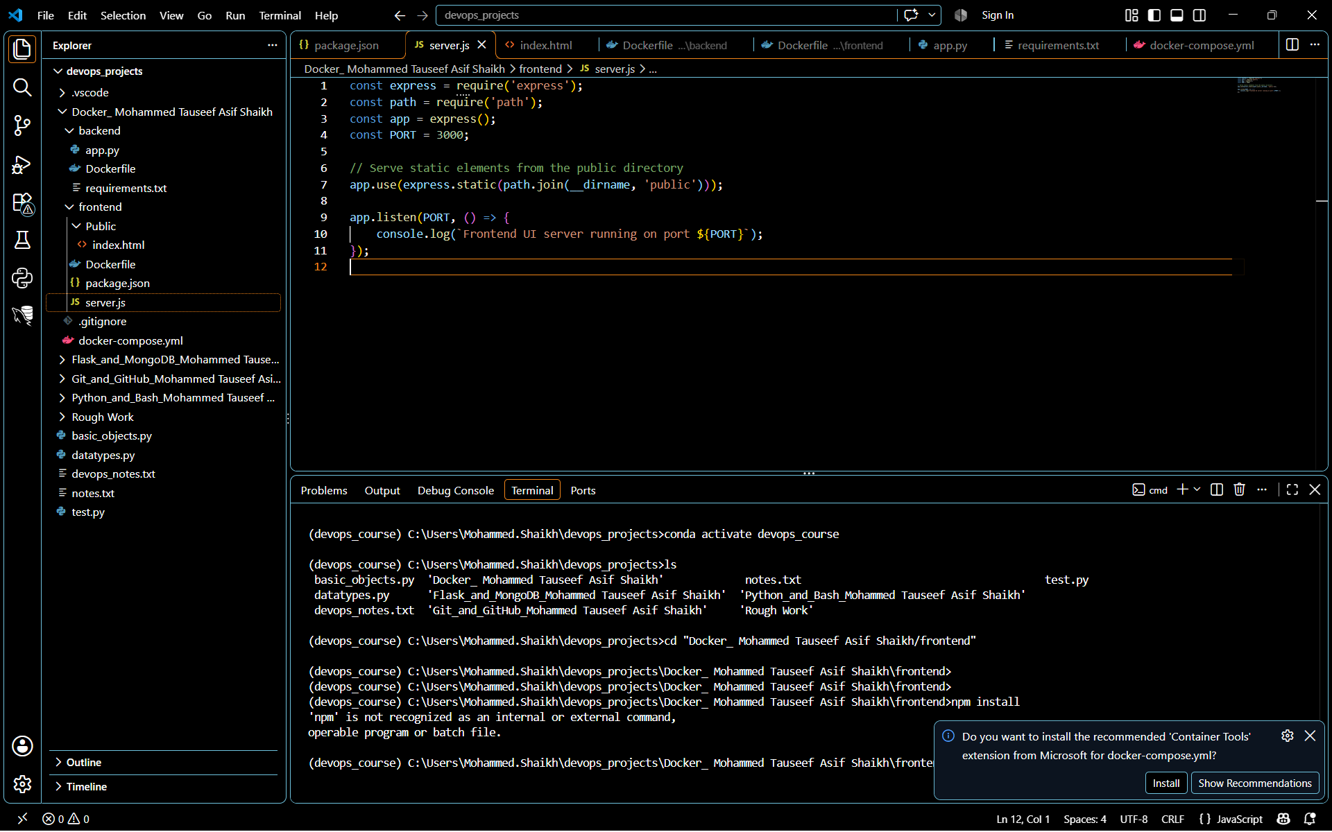

- Include a form similar to the one from the Flask Assignment 2.

Explanation- Create the web form user interface (index.html) that matches prior Flask assignment to capture an Item Name and Item Description.

Source Code-

<!DOCTYPE html>
<html lang="en">
<head>
<meta charset="UTF-8">
<meta name="viewport" content="width=device-width, initial-scale=1.0">
<title>DevOps To-Do Form</title>
<style>
body { font-family: Arial, sans-serif; margin: 50px; background-color: #f4f4f9; }
.form-container { max-width: 400px; background: white; padding: 25px; border-radius: 8px; box-shadow: 0 4px 8px rgba(0,0,0,0.1); }
.form-group { margin-bottom: 15px; }
label { display: block; margin-bottom: 5px; font-weight: bold; }
input, textarea { width: 100%; padding: 8px; box-sizing: border-box; border: 1px solid #ccc; border-radius: 4px; }
button { background-color: #007bff; color: white; border: none; padding: 10px 15px; border-radius: 4px; cursor: pointer; width: 100%; }
button:hover { background-color: #0056b3; }
#message { margin-top: 15px; font-weight: bold; color: green; }
</style>
</head>
<body>

<div class="form-container">
<h2>Add To-Do Item</h2>
<form id="todoForm">
<div class="form-group">
<label for="itemName">Item Name:</label>
<input type="text" id="itemName" required>
</div>
<div class="form-group">
<label for="itemDescription">Item Description:</label>
<textarea id="itemDescription" rows="4" required></textarea>
</div>
<button type="submit">Submit to Backend</button>
</form>
<div id="message"></div>
</div>

<script>
document.getElementById('todoForm').addEventListener('submit', async (e) => {
e.preventDefault();
const itemName = document.getElementById('itemName').value;
const itemDescription = document.getElementById('itemDescription').value;
const messageDiv = document.getElementById('message');

try {
// Sends form data directly to the Flask backend container on port 5000
const response = await fetch('http://localhost:5000/api/submit', {
method: 'POST',
headers: { 'Content-Type': 'application/json' },
body: JSON.stringify({ itemName, itemDescription })
});
const data = await response.json();
messageDiv.innerText = data.message || "Submission status: " + data.status;
messageDiv.style.color = "green";
} catch (error) {
messageDiv.innerText = "Error linking with backend container.";
messageDiv.style.color = "red";
}
});
</script>
</body>
</html>

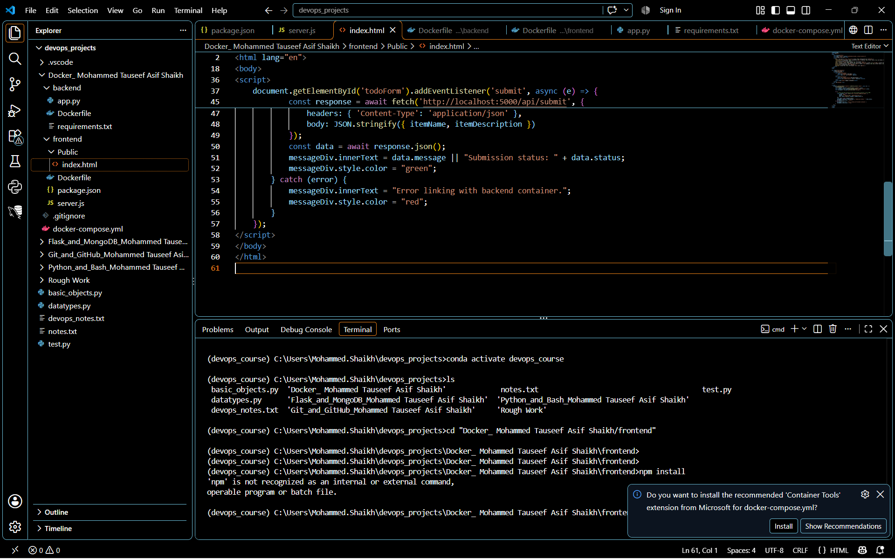

- Configure the form to send a request to the Flask backend.
In the previous step, the form is already configured to communicate with your Flask API. Here is the exact part of the code inside your frontend/public/index.html file that fulfils this requirement:
// Sends form data directly to the Flask backend container on port 5000
const response = await fetch('http://localhost:5000/api/submit', {
method: 'POST',
headers: { 'Content-Type': 'application/json' },
body: JSON.stringify({ itemName, itemDescription })
});

Explanations-
- Target Endpoint (http://localhost:5000/api/submit): This maps to the port 5000 where your Flask application will run inside Docker. Even though they live in separate containers, the browser executes this script on your local computer, sending the traffic to port 5000.
- Method (POST): Sends the data securely as a request payload rather than exposing it in the URL string.
- Payload Serialization (JSON.stringify): Converts the input text values dynamically into standard JSON format so the Python/Flask backend can parse it effortlessly.
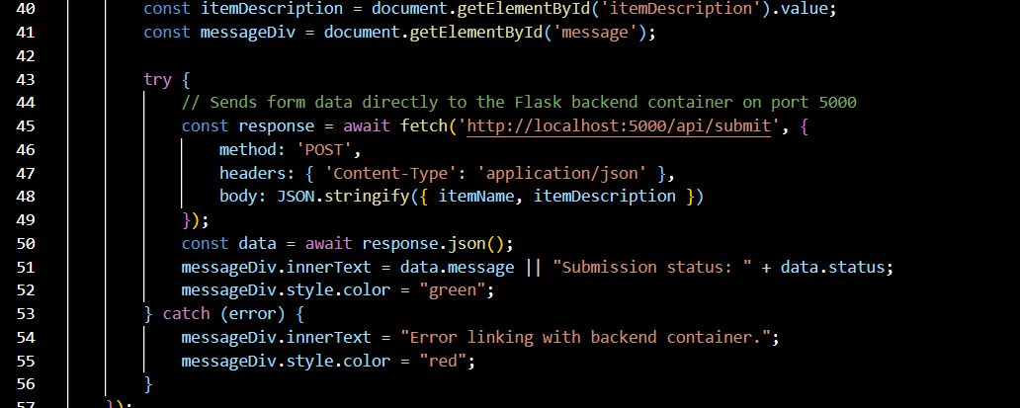

2. Backend (Flask)
- Use the Flask backend to handle the form submission and process the data.
Now I build the backend API using Flask. This service will run on port 5000 to receive the data submitted by frontend, process it, and send a reply back to the browser.

Explanation- This code defines an API route (/api/submit) that listens for incoming POST data, decodes the JSON body, prints the values to the terminal, and responds with a success status.

Source Code-
from flask import Flask, request, jsonify
from flask_cors import CORS

app = Flask(__name__)
# Enable CORS so the Node.js frontend can communicate with this API
CORS(app)

@app.route('/api/submit', methods=['POST'])
def handle_submission():
data = request.json
if not data:
return jsonify({"status": "error", "message": "No data received"}), 400

item_name = data.get('itemName')
item_description = data.get('itemDescription')

# Print the values to the container log console
print(f"Received Item: {item_name} - {item_description}", flush=True)

# Return verification response back to the frontend
return jsonify({
"status": "success",
"message": f"Successfully processed item: {item_name}!"
}), 200

if __name__ == '__main__':
# Listen on all local container interfaces on port 5000
app.run(host='0.0.0.0', port=5000)
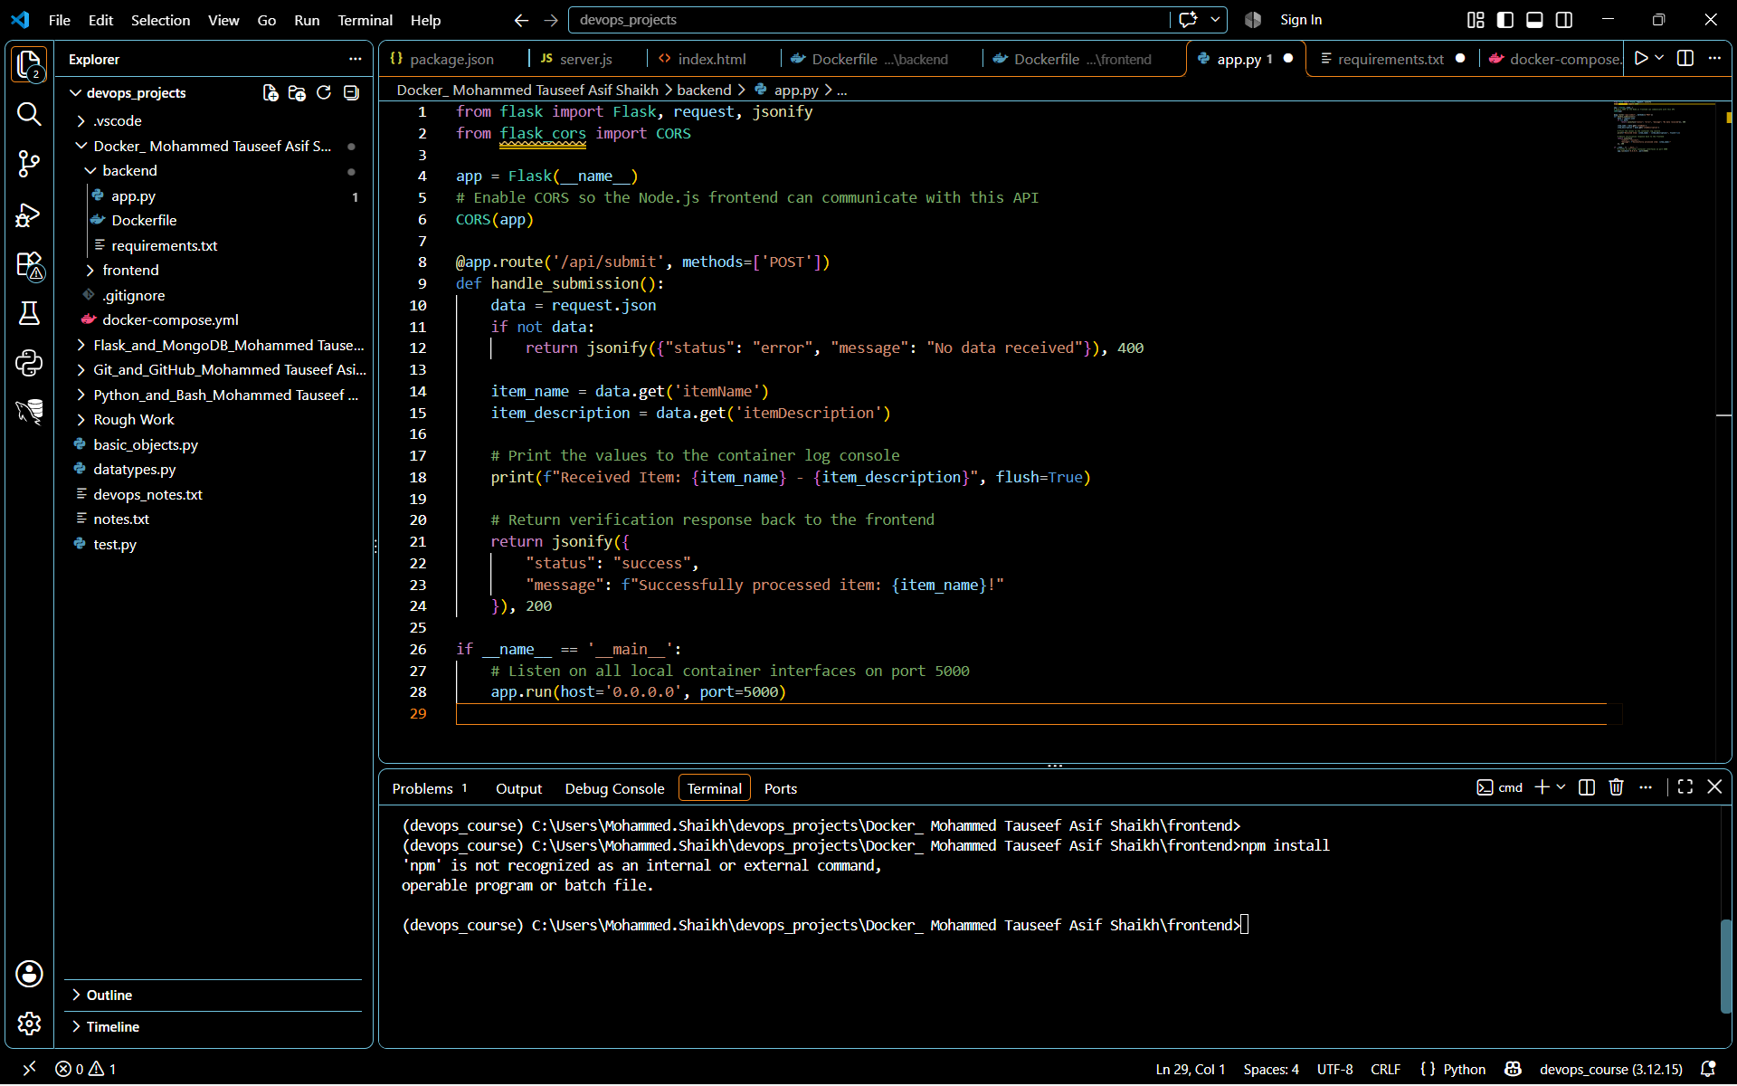
Explanation- backend/requirements.txt: This file acts as a manifest listing the exact Python libraries required by your environment.
Source Code-
flask==3.0.3
flask-cors==4.0.1
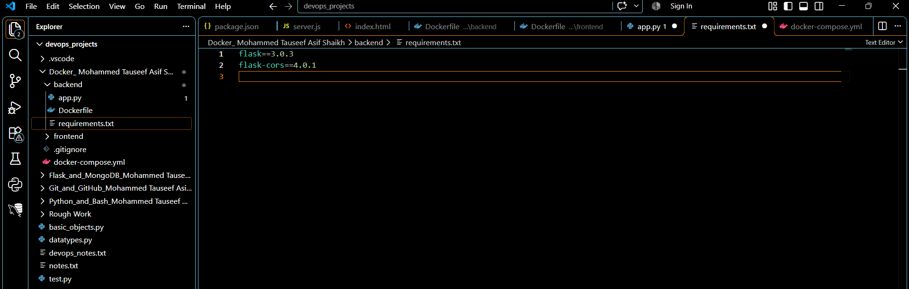
3. Folder Structure
- Organize the project with separate folders for the frontend and backend.
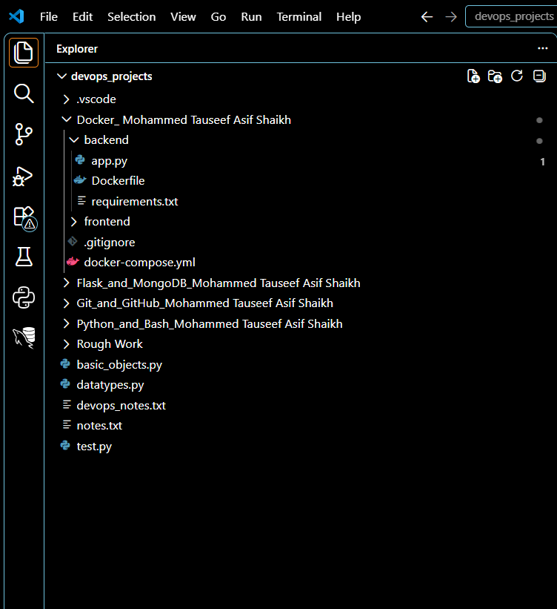

4. Docker Configuration
- Create a Dockerfile for both the frontend and backend.
Now configure Docker to know how to install dependencies and run both services independently. A Dockerfile acts as a step-by-step blueprint for building a container image.
Explanation- frontend/Dockerfile this file instructs Docker to use a lightweight Node.js image, copy the package details, download the project code modules internally, and spin up the Express server.
Source Code-
# Use an official, lightweight Node runtime base image
FROM node:20-slim

# Set the working directory inside the container
WORKDIR /app

# Copy the dependency manifest file first to leverage Docker caching layers
COPY package.json .

# Install dependencies inside the isolated container filesystem
RUN npm install

# Copy the rest of the application files (like server.js and public/)
COPY . .

# Expose port 3000 to allow traffic into the container
EXPOSE 3000

# Specify the command to start the Express UI server
CMD ["node", "server.js"]
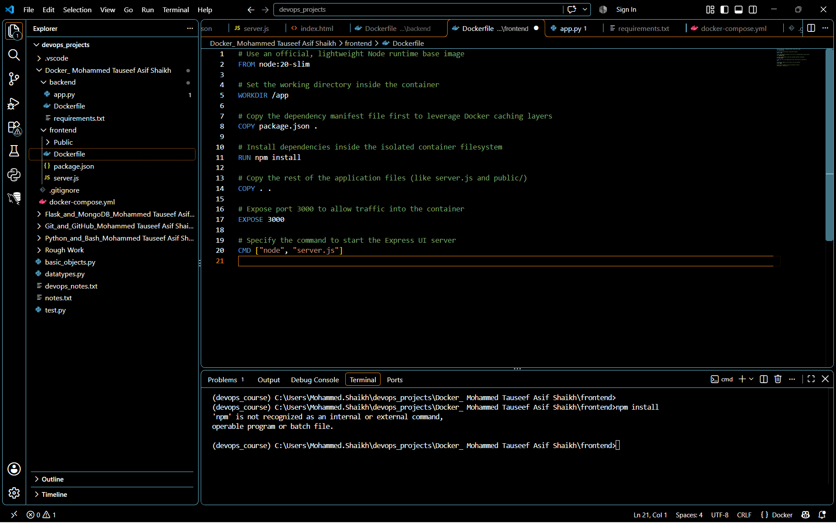

Explanation- backend/Dockerfile this file instructs Docker to pull a clean Python environment, copy the module requirements, install Flask/CORS internally, and run the API application script.

Source Code-
# Use an official, lightweight Python runtime base image
FROM python:3.12-slim

# Set the working directory inside the container
WORKDIR /app

# Copy the package requirement definitions list
COPY requirements.txt .

# Install application dependencies using pip cleanly without saving cache space
RUN pip install --no-cache-dir -r requirements.txt

# Copy all local project source scripts into the container filesystem
COPY . .

# Expose port 5000 to accept incoming network routing traffic
EXPOSE 5000

# Execute the Flask application startup command
CMD ["python", "app.py"]

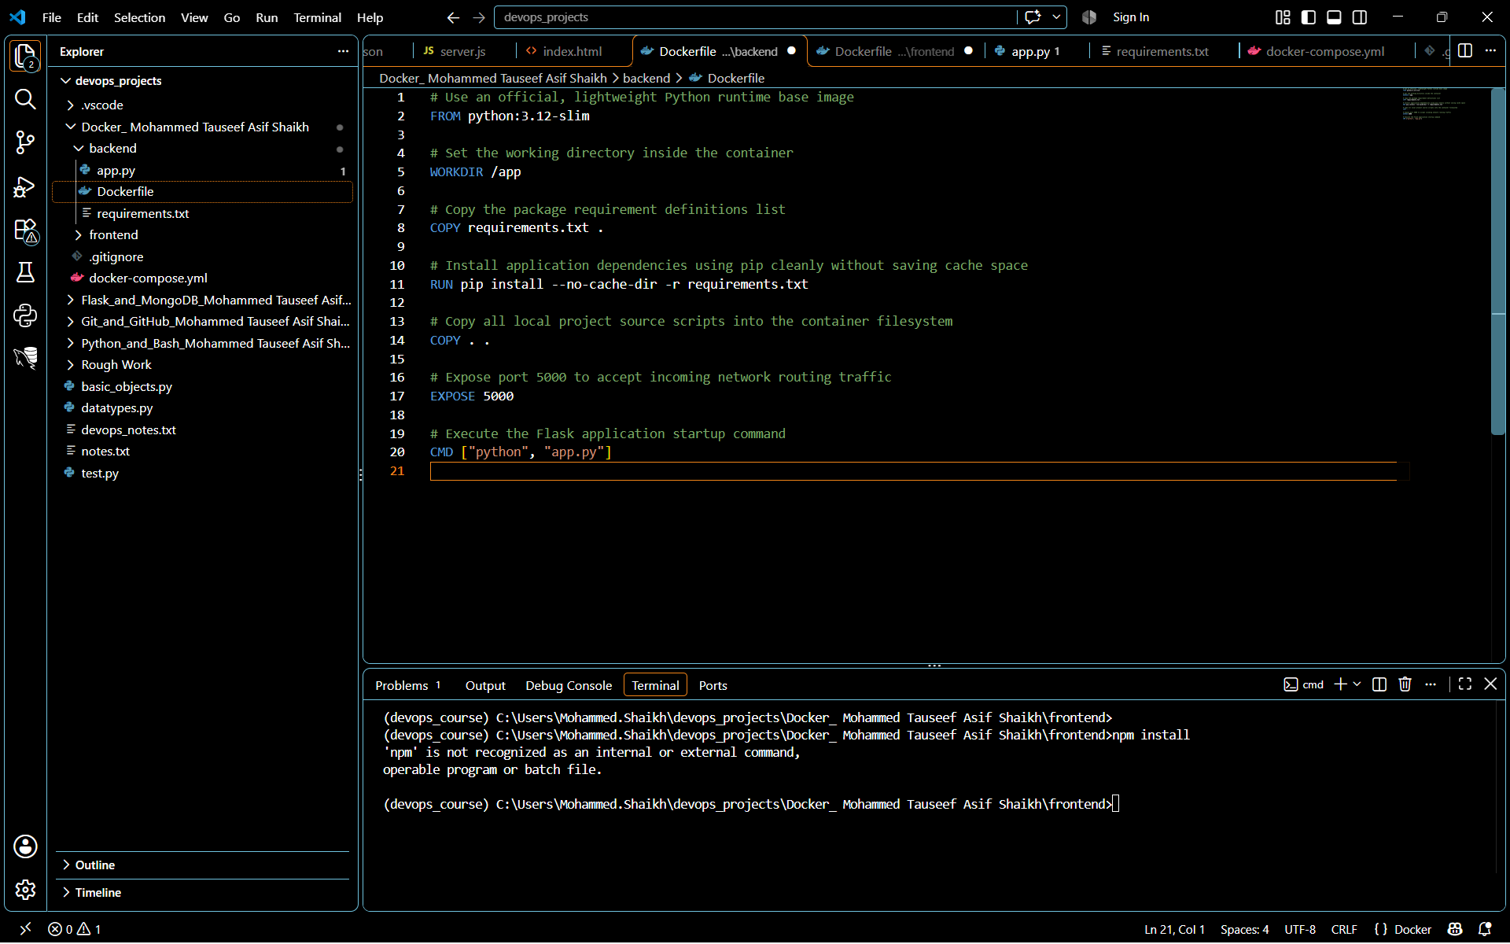

- Write a .yaml file (Docker Compose) to connect both services in the same network.

Now create a Docker Compose file (docker-compose.yml) in the root directory.
Explanation- This configuration automates the building, launching, and networking of both your frontend and backend containers together with a single execution step.

Source Code-
version: '3.8'

services:
# Frontend UI Service
frontend:
build: ./frontend
container_name: express_frontend
ports:
- "3000:3000"
restart: always

# Backend API Service
backend:
build: ./backend
container_name: flask_backend
ports:
- "5000:5000"
restart: always

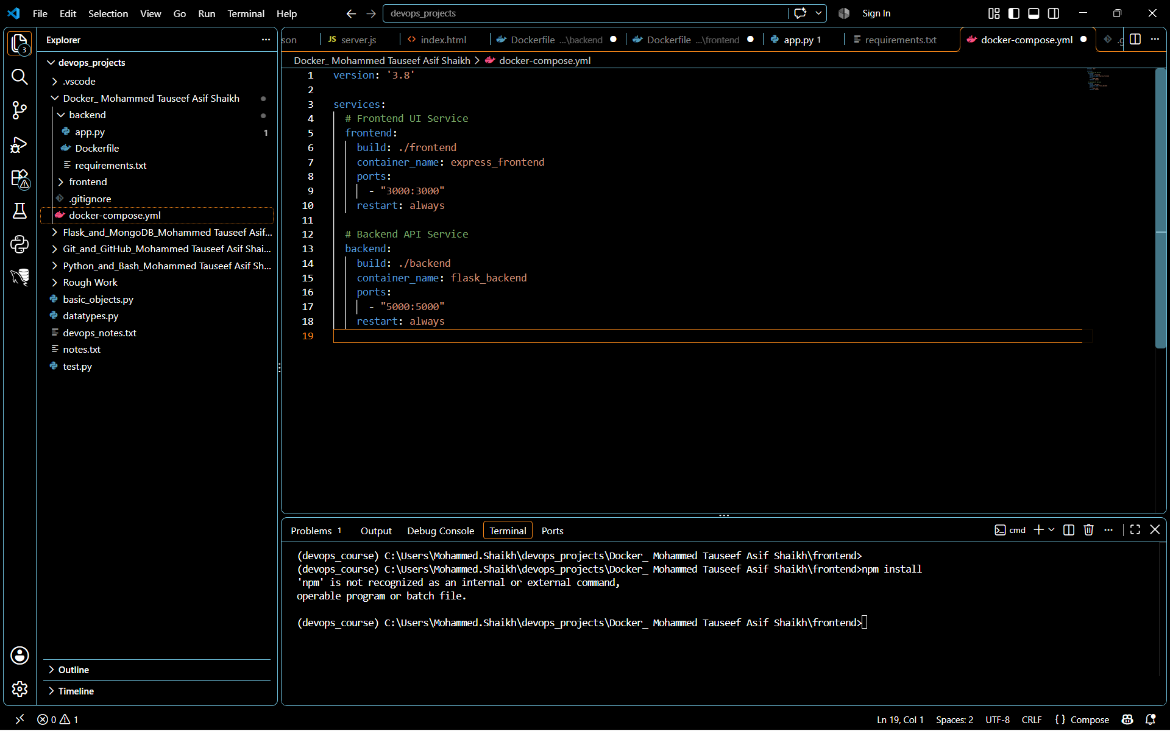

Explanations-
- build: Directs Docker Compose to look inside the ./frontend and ./backend directories to locate the individual Dockerfile blueprints we made in the last step.
- ports: Maps the ports from inside the isolated container networks out to your local machine (localhost). Port 3000 allows you to view the frontend webpage, and port 5000 allows the frontend form requests to arrive smoothly at the Flask container.
- container_name: assigns explicit friendly names (express_frontend and flask_backend) to avoid randomly generated system naming structures when viewing container logs.

- Upload both images to Docker Hub, and push your whole code to GitHub. Add node_modules and other non-required files (e.g., .vscode) to .gitignore.
***Note: Since I am using my company device, I do not have admin access or permission for WSL. Therefore, I am using a public, free Docker sandbox to complete this assignment.***
Next Step: Local Multi-Container Stack Launch
Explanation- Ran these commands in an active cloud terminal window to build the application containers:
Source Code-
# Build the images and start the container stack in detached (background) mode
docker compose up --build -d

# Verify that both containers are successfully up, active, and healthy
docker compose ps

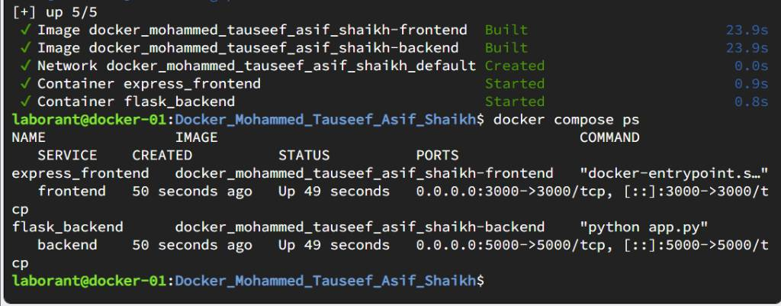
Next Step: Upload Both Images to Docker Hub
Explanation: Now we will log into personal Docker Hub account from this online terminal, tag the compiled local sandbox images, and push them to public repository.
Source Code- Run these commands one by one in your active terminal:

# 1. Log into your Docker Hub account (it will prompt you for your username and password/token)
docker login

# 2. Tag your locally compiled frontend image with your Docker Hub namespace
docker tag docker_mohammed_tauseef_asif_shaikh-frontend:latest tauseefclaratte/express-frontend:latest

# 3. Tag your locally compiled backend image with your Docker Hub namespace
docker tag docker_mohammed_tauseef_asif_shaikh-backend:latest tauseefclaratte/flask-backend:latest

# 4. Push the frontend image up to your Docker Hub repository
docker push tauseefclaratte/express-frontend:latest

# 5. Push the backend image up to your Docker Hub repository
docker push tauseefclaratte/flask-backend:latest



